Moving beyond the Garden
Creating your Schoolyard Outdoor Classroom
A National Wildlife Federation Schoolyard Habitats® Webinar Series
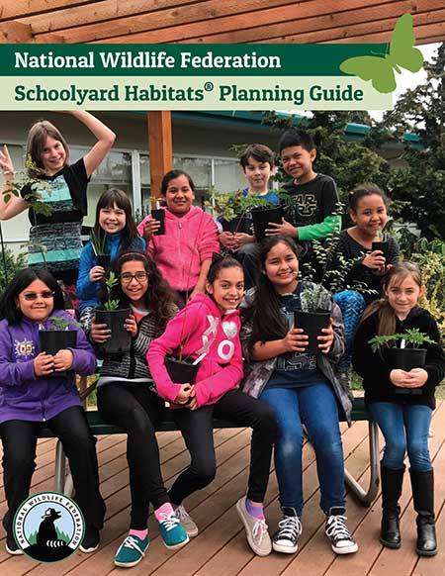
Join the National Wildlife Federation for a 4-part webinar series designed around our new Schoolyard Habitats® Planning Guide. Our first webinar will be on October 6, 2021 from 6:30 – 7:30 EST. We invite you to join to hear from a panel of practicing teachers from across the U.S., including Marcia Cardona from Royal Palm Elementary, Miami, FL; Janson Siptak from Bonham Academy, San Antonio, TX and Kara Contreras, from Brixner Junior High School, Klamath Falls, OR. These amazing educators will share their knowledge and experience in developing a team, creating community, assessing and designing the site and implementation and maintenance. Q&A with the audience will follow.

Future webinars will dig into topics such as best practices for teaching outdoors and how to expand and maintain your habitat for outdoor learning.
Follow @EcoSchoolsUSA on Twitter and Facebook for more details and registration links for future webinars.
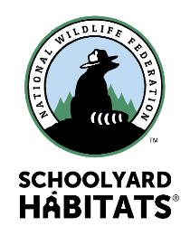
Register Here for the October 6th Webinar

